Instructions:
- Graphics, audio or video files are not provided in this document for download, only for reference. Please download the high-resolution files from your partner folder.

Email 1
Subject line: Want to wake up to new bookings? ☕

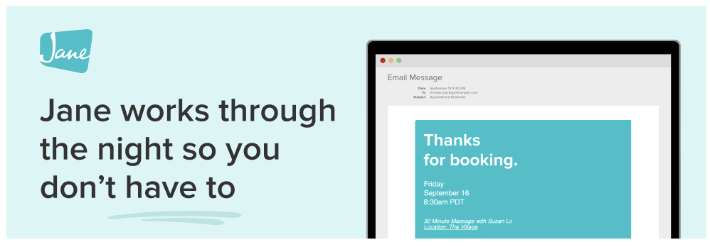
Hi there [name of community],
I’m Maddy, here to tell you a bit about Jane.
Jane is a practice management software and EMR designed to support your day-to-day work of running a practice. While Jane can’t make your morning coffee (unfortunately), it can help you start the day on the right foot.
With online booking, your schedule can fill up while you sleep, giving your patients the freedom to manage their care, and giving you one less thing to coordinate. In fact, nearly 20% (1 in 5) appointments are booked either after hours or on weekends, based on client appointments made with Jane clinics between May 2024 and May 2025.
But Jane does more than just manage online booking. It also keeps things running smoothly with automatic reminders and intake forms, so your patients arrive prepared and on time.
If you’d like to learn more about what Jane can do for your practice and your patients, you can book a demo with the team.
And, if you’re ready to get started, use the code [CODE HERE] for a 1-month grace period on your new account.
Thanks for having me in your inbox,
Maddy (on behalf of the Jane team). 💙
*optional dedication line/sign off

